
Tribhuvan University
Institute of Science and Technology
A Report On
“Daily Journal with CRUD operation”
In partial fulfillment of the requirements
For the Bachelors of Science in Computer Science and Information Technology
Submitted by:
Deepan Paudel (79011060)
Ristika Maharjan (79011074)
Anuska Gaire (79011055)
Lalita Pun Magar((79011064)

Asian College of Higher Studies
Ekantakuna, Lalitpur
November 2025
Under the supervision of:
Mr. Bidur Sapkota

Certificate of Approval
This is to certify that Ristika Maharajan, Deepan Paudel, Anuska Gaire, and Lalita Pun Magar have submitted satisfactory report entitled “Daily Journal with CRUD operation” under the supervision of the respective teacher Mr. Bidur Sapkota as the partial fulfillment for the degree of Bachelor of Science in Computer Science and Information Technology (BSc. CSIT), Institute of Science and Technology, Tribhuvan University.
The project has been reviewed and deemed satisfactory by the evaluating authority.

Date: …………………………………

…………………………
Signature of Supervisor
Mr. Bidur Sapkota

ACKNOWLEDGEMENT
We would like to express my heartfelt gratitude to my facilitator, Mr. Bidur Sapkota, for his invaluable guidance, encouragement, and constructive feedback throughout the development of this project. His continuous support and insightful suggestions have been instrumental in shaping this work into its final form.
We are also deeply thankful to my friends, classmates, and seniors who provided both direct and indirect support during the course of this project. Their cooperation, motivation, and timely assistance played a significant role in helping us overcome challenges and complete the work within the given time frame.
Lastly, we would like to thank our classmates, family, and friends for their constant motivation and assistance during the preparation of this compilation. Without their support, this work would not have been possible.

Sincerely,
Deepan Paudel
Ristika Maharjan
Anuska Gaire
Lalita Pun Magar

ABSTRACT
This project presents Daily Journal, a backend CRUD API system developed to manage personal journal entries through well-structured and encrypted RESTful endpoints. The project emphasizes secure data handling, proper documentation, validation, and testing while showcasing the use of configuration and collaboration tools in modern software development.
The application is created using Java script with the Spring Boot framework for the backend logics and MySQL for database management. It provides APIs that allows users to perform the CRUD operation to the journal entries while ensuring the security through JWT (JSON Web Token)-based authentications and authorization. Comprehensive data validation is applied at both the input and service levels, supported by extensive unit and integration testing to verify functionality and reliability. Interactive API documentation is generated using Swagger (OpenAPI), allowing developers to explore, test, and understand each secured endpoint efficiently.
The project also utilizes Git for version control, GitHub for repository hosting, and Trello for the task management and team collaboration, ensuring transparency, structured development, and traceability throughout the lifecycle. By integrating security mechanisms, testing frameworks, and documentation tools, Daily Journal demonstrates a complete backend solution for secure CRUD operations, emphasizing reliability, maintainability, and data protection.
Keywords: CRUD API, Java, Spring Boot, MySQL, Swagger, OpenAPI, Data Validation, Testing, Git, GitHub, Trello, Secure Backend Development

Table of Contents
Certificate of Approval I
ACKNOWLEDGEMENT II
ABSTRACT III
LIST OF ABBERVIATIONS VI
LIST OF FIGURES VII
LIST OF TABLES VIII
Chapter 1: Introduction 1
1.1 Background 1
1.2 Objectives 1
1.3 Scope and Limitations 2
1.4 Development Methodology 2
1.5 Report Organization 3
Chapter 2: Background Study and Literature Review 5
2.1 Background Study 5
2.2 Literature Review 5
2.2.1 Thematic Review 5
2.2.2 Theoretical Review 6
2.2.3 Conceptual Review 7
Chapter 3: System Analysis 8
3.1 System Analysis 8
3.1.1 Requirement Analysis 8
3.1.2 Feasibility Analysis 9
3.1.3 Analysis 11
Chapter 4: System Design 17
4.1 Design 17
4.1.1 Database Design 17
4.1.2 Forms and Report Design 19
4.1.3 Interface and Dialogue Design 19
4.1.4 Component Diagrams 20
4.1.5 Deployment Diagrams 20
Chapter 5: Implementation and Testing 22
5.1 Implementation 22
5.1.1 Tools Used 22
5.1.2 Implementation Details of Modules 23
5.2 Testing 26
5.2.1 Test Cases for API/Functional Testing 26
5.2.1 Test Cases for System Testing 27
5.3 Result Analysis 29
Chapter 6: Conclusion 30
6.1 Future Enhancement 30
6.2 Conclusion 30
References 31
APPENDIX 33

LIST OF ABBERVIATIONS
CRUD Create, Read, Update, and Delete
REST Representational State Transfer
API Application Programming Interface
JWT JSON Web Token
OWASP Open Web Application Security Project
GUI Graphical User Interface
UI User Interface
PK Primary Key
FK Foreign Key
ER Entity Relationship
UX User Experience
CASE Computer-Aided Software Engineering

LIST OF FIGURES
Figure 1: Waterfall Model 3
Figure 2: Use case Diagram 8
Figure 3: ER Diagram 11
Figure 4: Class Diagram 12
Figure 5: Object Diagrams 13
Figure 6: State Diagram of Journal Lifecycle 14
Figure 7: Sequence Diagram for creating Journal Entry 15
Figure 8: Activity Diagram 16
Figure 9: ER Diagram (4.1) 17
Figure 10: Component Diagram 20
Figure 11: Deployment Diagram 21
Figure 12: Trello Proof 33
Figure 13: Spring Initializer 33
Figure 14: git commit proof 34
Figure 15: Git Command Proof 34
Figure 16: Pull Request Proof 34
Figure 17: Pull request (new feature is ready to be merged) 35
Figure 18: Pull request (sucessfully merged) 35

LIST OF TABLES
Table 1: User Table (Ch 4.1.1)18
Table 2: Entry Table (Ch 4.1.1)18
Table 3: Test Cases for API/Functional Testing27
Table 4: Test Cases for System Testing29

Chapter 1: Introduction

Background
In today’s digital era, technology plays a vital role in how people record, organize, and secure their personal thoughts and daily activities. With increase in the shift from the paper-based journalism to digital platforms ensuring the data security and privacy has become an important concern. User expect their digital journaling tools to be safe, reliable, and accessible across devices.
The Daily Journal project aims to create a simple yet secure backend system that supports the core CRUD operations for managing journal entries. The system ensures that all user interactions are authenticated and authorized using JSON Web Tokens. JSON Web Token (JWT) is a compact, URL-safe means of representing claims to be transferred between two parties. [1]
The backend in built with Spring Boot, a Java framework that simplifies the development of scalable, production-ready applications [2]. It integrates with MySQL, an open-source relational database system known for its robustness and ease of use [3]. To make the system developer-friendly, the project also uses Swagger/OpenAPI for generating interactive API documentation [4].
Security consideration is guided by the principles from OWASP Top 10, which outlines the most common security risks in web applications [5]. Version Control and Collaboration are maintained using Git and GitHub, while Trello is employed to manage project tasks, reflecting the simultaneous development, and teamwork [6].
Overall, Daily Journal represents a secure and maintainable backend system that combines modern development practices, security principles, and collaboration tools to deliver a complete and reliable journaling solution.

Objectives
The primary objectives of this project are to:
- Develop a secure backend API that supports CRUD operation for user journal entries.
- Apply data validation to maintain consistency and reliability.
- Generate interactive API documentation using Swagger/OpenAPI.
- Conduct unit and system testing to verify application correctness.
- Utilize Git, GitHub, and Trello for version control and team collaboration.

Scope and Limitations
This project solely focuses on the backend development, with no GUI. It includes secure CRUD operations, user authentication, and API documentations. The system can later be integrated into a full-stack web or mobile application. Future enhancement could include deploying the API on cloud servers, integrating user analytics, etc.

Development Methodology
For the development of the Daily Journal Backend System, the Waterfall Development Methodology as it provides a structured approach for projects with clear and well-defined requirements.
The development process began with detailed Requirements Analysis to gather and document all system needs such as the functional and non-functional requirements. Once the requirements were finalized, the project moved to the System and Design phase, where the system architecture, database schema were planned. Similarly, in Implementations the system was developed based on the approved design specifications. After implementation, the Testing phase was conducted to verify the correctness, functionality, and performance of each component.
To support the Waterfall stages, GitHub was used for version control and maintaining proper documentation of development progress and code updates. Trello was utilized as a task management and sprint planning tool to assign tasks, track progress, monitor workflow, and maintain transparency within the team.
The Waterfall approach was particularly suitable for this project because the system requirements were stable and clearly defined from the beginning. The model ensured detailed planning, proper documentation, and a disciplined execution process, allowing the team to deliver a well-tested, reliable, and structured Daily Journal Backend System.
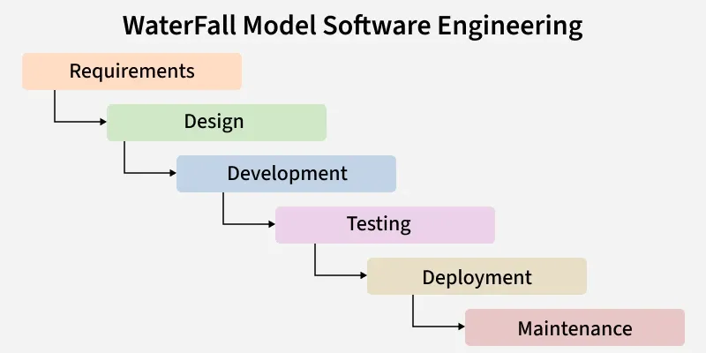
Figure 1: Waterfall Model

Report Organization
This report presents the development of exclusive backend functionality emphasizing the secure data transaction and RESTful API design with no frontend or UI components implemented. The report is organized into six chapters:
Chapter 1: Introduction includes the introduction to the project highlighting its objectives and methodology. Scopes and Limitations of the projects are also mentioned in this chapter.
Chapter 2: Literature Review covers the background of the study and analysis of the related works, and related research papers.
Chapter 3: System Analysis outlines the functional and non-functional requirements of the system, with a feasibility study consisting of technical, operational, economic and schedule aspects.
Chapter 4: System Design highlights system design overview, design with diagram and architecture models.
Chapter 5: Implementation and Testing define the implementation of system ensuring smooth development, testing, and result analysis.
Chapter 6: Conclusion describes the description of system’s feature that are executed as well as the future enhancement that are yet to be implemented into the system.

Chapter 2: Background Study and Literature Review

Background Study
Digital Journaling has gained popularity due to its convenience, accessibility, and enhanced security offered by the online platforms as well as portability. Traditional paper journals while tangible, are limited by their lack of their portability, and protection against being lost and damaged. Digital system addresses these challenges by offering cloud storage, encryption, and structured access control, allowing users to maintain their personal records efficiently [8].
A critical component of such system is the backend infrastructure, which manages the storage, retrieval, updating, and deletion of user data. Modern backend system is expected to support CRUD operation reliably, maintain data integrity, and enforce strict security mechanisms to protect sensitive information [1]. Additionally, backend APIs must be well-documented and standardized to allow integration with other applications or services [4].

Literature Review

2.2.1 Thematic Review

2.2.1.1 Problems with Existing System
Many existing journalism platforms either lack strong security or fail to provide standardized APIs for developers. Some system sensitive user data without proper encryption or session management, increasing the risk of breaches [5]. Inadequate input validation also results in inconsistent or corrupted data. These issues indicate the need for system that prioritized data security, validation, and maintainable API design. For example: Daylio Journal, a widely used journaling or mood tracking app that in a study was found to have design and permission handling issues that undermine its reliability and user trust. [9] [10]

2.2.1.2 Current Technologies Used
Morden Backend system typically uses combination of framework, database, security mechanism, documentation tools, testing tools, and collaboration platforms to ensure efficiency, reliability, and maintainability. Spring Boot (Java) provides a powerful framework for building scalable RESTful APIs with embedded servers and pre-configured modules that simplify security and database connectivity [2]. MySQL is commonly used as a relational database to store persistent user information and journal entries [3]. To secure API endpoints and verify user identity without maintaining server-side sessions, JWT (JSON Web Token) authentication is widely adopted [1]. Swagger/OpenAPI is employed to generate interactive API documentation, helping developers easily understand endpoints, request-response structures, and error handling processes [4]. Finally, for collaboration and version control, tools such as Git, GitHub, and Trello is used to support team-based development, task management, and enables the smooth transition and coordination between the teammates.

2.2.1.3 Potential Technologies
Future enhancements for the system could include advanced security measures like role-based access control or OAuth2 integration to further protect user data. Cloud-based storage and deployment may be added to improve scalability and accessibility, while AI-driven features, such as sentiment analysis or automatic categorization of journal entries, could make the journaling experience smarter and more personalized.

2.2.2 Theoretical Review
The development of the Daily Journal is backed by several established theories and concept from software engineering, web architecture, and security. Such as REST (Representational State Transfer) architectural style provides the foundation for designing scalable and stateless web services, emphasizing resource-oriented endpoints and the standard use of HTTP methods for CRUD operations [8]. Similarly, to secure the system, JSON Web Token (JWT) authentication is employed, based on the theory that digitally signed, stateless tokens provide a reliable mechanism for verifying user identity and authorizing access to resources [1]. JWT allows the server to validate each request without storing session state, aligning with modern best practices for scalable and secure API design. Software quality and testing theories, particularly those from Extreme Programming (XP) and Test-Driven Development (TDD), emphasize iterative development, continuous testing, and code reliability [7].
From a development methodology perspective, the project employs waterfall model so that the project can be moved with the systematic and structured order. Using tools such as Git, GitHub, and Trello, the team manages code, tracks tasks, and coordinates development in sprints, allowing continuous improvement and adaptability to changing requirements.
Finally, API documentation and contract-first design theories emphasize defining a clear specification before implementation, improving developer usability, reducing integration errors, and ensuring maintainable code [4]. By documenting all endpoints, request-response schemas, and error responses using Swagger/OpenAPI, the project establishes a reliable contract for developers and testers, supporting transparency and consistency throughout the system lifecycle.

2.2.3 Conceptual Review
The Daily Journal is designed to provide a secure, reliable, and maintainable platform for managing personal journal entries. At its core, the system enables CRUD operations for journal entires. To ensure security, JWT-based authentication verifies user identity and enforces authorization for every request, eliminating the need for server-side session storage [1].Junit has been used to automation and validation test cases while Swagger/OpenAPI documentation is used to provide a clear contract for developers, facilitating integration and maintainability [4]. These components interact with a MySQL database, storing user data securely. The development process follows Waterfall model for the linear and sequential systematic phases such that it ensures that development of the specific phase is finished before moving to the next phase. The research hypothesis states that implementing this combination of RESTful CRUD operations, JWT security, data validation, and documentation will significantly enhance the security, reliability, and usability of journaling platforms compared to existing systems.

Chapter 3: System Analysis

System Analysis
The system analysis phase focuses on understanding the requirements, feasibility, and overall design approach of the Daily Journal backend system. It aims to ensure that the system will meet user expectations while remaining reliable, secure, and maintainable.

3.1.1 Requirement Analysis
- Functional Requirements
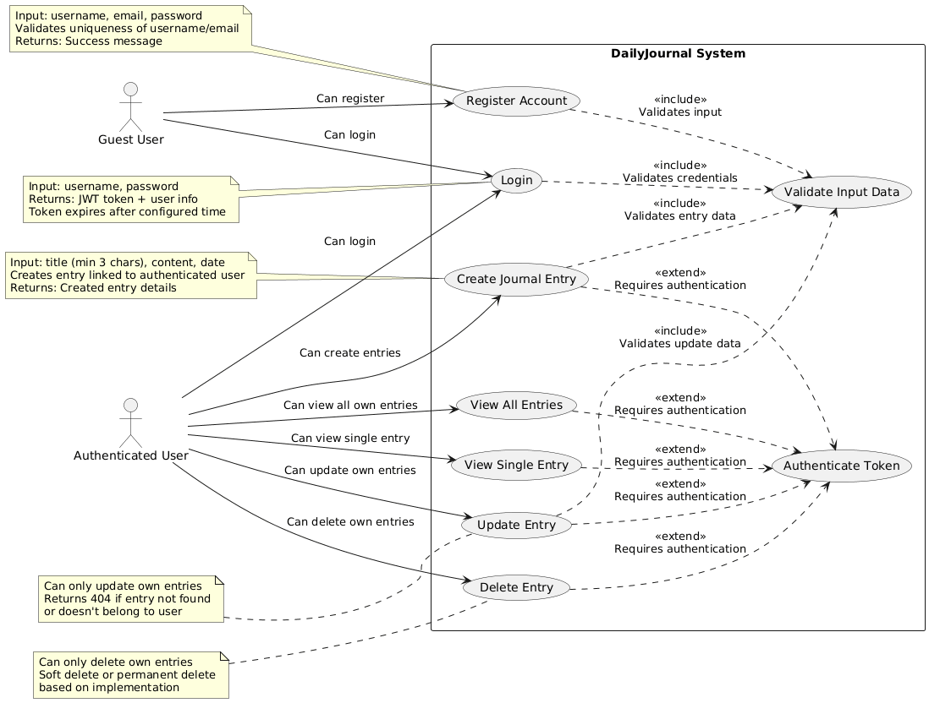
Figure 2: Use case Diagram

The Daily Journal system is designed to support several core functionalities to ensure that user have a seamless, secure, and efficient journaling experience. First, user registration and authentication allow users to securely register, log in, and log out through JWT tokens, ensuring that only authorized individuals can access their data. The system also provides CRUD operations for journal entries, enabling users to create, read, update, and delete their entries with ease. Data validation ensures that all user inputs are complete, formatted correctly, and contain allowed values, preventing errors or inconsistencies. o further enhance security, only authenticated users or authorized can access their own journal entries, ensuring privacy and data protection. Additionally, API documentation is provided using Swagger/OpenAPI, giving developers clear insights into available endpoints, request-response structures, and potential errors. Finally Junit guarantees the correctness and stability while ensuring reliability in the system’s performance.

- Non-Functional Requirements
It must also meet several non-funtional requirements to ensure that it operates efficiently, securely, and is easy to maintain.
- Performance is a key consideration: the application should offer low latency for operations.
- Scalability is also crucial; the system should be able to handle increased user load during peak traffic by scaling horizontally without compromising performance.
- Maintainability is required: the system should be designed to support easy updates and changes, allowing for seamless upgrades without data loss.
- Security plays a vital role in protecting user data. All user information must be encrypted, and the APIs should be secured to prevent unauthorized access, ensuring data privacy and trust.

3.1.2 Feasibility Analysis
The feasibility analysis of the Daily Journal is done to examine the practicality of the system in terms of technical, economic, operational, and schedule feasibility. Each of these aspects has been considered to ensure the success of the project.
- Technical Feasibility
The technical feasibility of the Daily Journal is possible given the tools and technologies chosen for development. Java with Spring Boot offers a robust framework for building scalable, secure, and efficient backend services, with extensive community support and well-documented libraries. MySQL is a suitable choice for the database, providing reliable and efficient relational data storage for journal entries. For authentication, the integration of JWT ensures secure, stateless user access control. Additionally, Swagger/OpenAPI will be used for API documentation, allowing both developers and testers to interact with and understand the system endpoints easily.

- Operational Feasibility
Daily Journal is operationally viable too with the clear and distinct phase in its development process: planning, system design, API development, database integration, authentication implementation, testing, and deployment. The development team is familiar with Java and Spring Boot, and they are also familiar with JWT authentication and MySQL database management, which reduces the learning curve. The system will be further refined through an iterative development process where regular testing and feedback will ensure the system meets performance, security, and usability standards.

- Economic Feasibility
From the point of view of economic feasibility, Daily Journal is cost-effective. The project uses open-source technologies such as Java, Spring Boot, and MySQL which eliminates the licensing costs. Tools like Swagger/OpenAPI are freely available. The infrastructure costs are scalable and will grow as the user base expands, ensuring the system remains affordable even with increased usage. Additionally, the use of widely adopted technologies means there is a lower cost for training and skill development for the team, reducing potential development expenses. Therefore, the system is economically feasible, and the cost-benefit ratio is favorable.

- Schedule Feasibility
The schedule feasibility of the Daily Journal backend system is assured through careful planning and task allocation. The project is divided into clear milestones, with tasks such as requirement analysis, system design, API development, user authentication, data validation, testing, and deployment each having specific time estimates. Due to that task being in the sequential order with the implementation of Waterfall methodology. Each phase of development is completed before the development of next stage. syr

3.1.3 Analysis
- Data Modeling using ER diagram
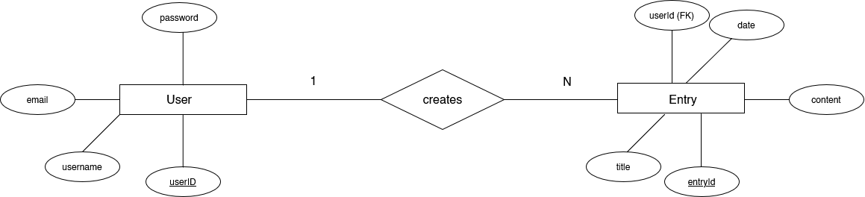
Figure 3: ER Diagram
The data model for the Daily Journal backend system is designed to manage users and their journal entries efficiently while maintaining referential integrity. The system consists of two primary entities: User and Entry. The User entity contains attributes such as userId (PK), username, email, and password with constraints to ensure uniqueness and mandatory values. he Entry entity represents individual journal entries and includes entryId (PK), title, content, data, and userID as a foreign key linking the entry to its owner. The relationship between the two entities is one-to-many: each user can create multiple journal entries, while each entry belongs to exactly one user. This structure enforces proper ownership and enables secure CRUD operations. The ER diagram visually represents these entities, their attributes, and the cardinality constraints, providing a clear blueprint for database design and implementation.

- Object Modelling using Class Diagrams
Object-oriented modelling helps in designing and visualizing the system’s structure, relationships between objects, and flow of the data.
Class Diagram
The Class Diagram represents the static structure of the system by showing its classes, their attributes, methods, and the relationships between them.
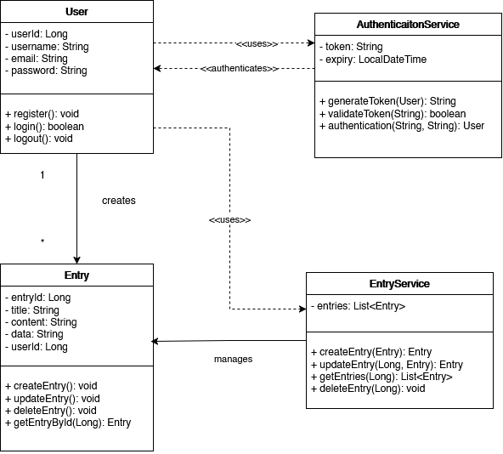
Figure 4: Class Diagram
The system consists of two primary entities: User and Entry class, and two service layers: EntryService and AuthenticationServices. User class represents a system user/account and handles user registration and authentication while maintaining user credentials and profiles. Similarly, Entry Class represents the journal/blog entry that belong to the specific user (via userId). CRUD operations are conducted in these entries. The AuthenticationServices manages the user authentication and token, generates and validates JWT tokens, and handles login/logout sessions while the EntryServices class hanldes CRUD operations for journal entries.

Object Diagram
Object diagrams are a visual representation in UML (Unified Modeling Language) that illustrates the instances of classes and their relationships within a system at a specific point in time.
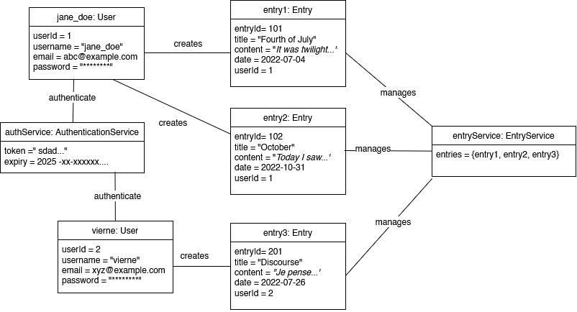
Figure 5: Object Diagrams
Here is the illustration of the simplified object diagram defining the relationships and current state of key components within a small content management system, likely for managing user entries or a blog. At the core, there are two distinct User objects: jane_doe (userId=1) and vierne (userId=2). Both users interact with an authService (AuthenticationService) via an authenticate relationship, which issues a security token with an expiry date. The users also exhibit a creates relationship with three separate Entry objects. Specifically, jane_doe created entry1 (ID 101, "Fourth of July") and entry2 (ID 102, "October"), while vierne created entry3 (ID 201, "Discourse"). Finally, all three created entries are collectively managed by the central entryService (EntryService) object, which holds them in its entries collection, demonstrating the aggregation of content by a service layer.

- Dynamic modelling using State and Sequence Diagrams
State Diagram: Journal Entry Lifecycle
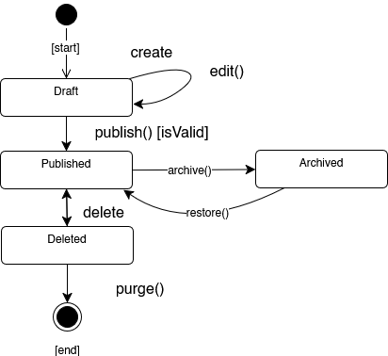
Figure 6: State Diagram of Journal Lifecycle
The State Diagram for a journal entry outlines the different states the entry goes through during its lifecycle and the transitions between these states. Initially, when a user creates a journal entry, it is in the New Entry state, where the entry is not yet saved. If the user makes modifications to the entry, it transitions to the Edited state. The entry remains in the Edited state until it is either saved, returning it to the "Saved" state, or deleted. If the entry is deleted by the user, it enters the Deleted state, making it inaccessible. Additionally, there is potential for an Archived state, where a journal entry may be moved to storage for future reference, providing an extra layer of organization. This lifecycle helps to manage journal entries effectively, ensuring users can modify, delete, or archive their entries as needed.

Sequence Diagram: Creating a Journal Entry
The process begins when the User sends a Create Entry request to the EntryService. The AuthenticationService then verifies the user's JWT token to ensure they are logged in and have the necessary permissions to create entries. Upon successful authentication, the EntryService processes the request, creating a new journal entry and storing it in the Database. Once the entry is successfully stored, the EntryService sends a response back to the User, confirming the creation with either a success message or an error, depending on the outcome. This sequence illustrates the interaction between the User, AuthenticationService, EntryService, and Database, ensuring a secure and organized process for journal entry creation.
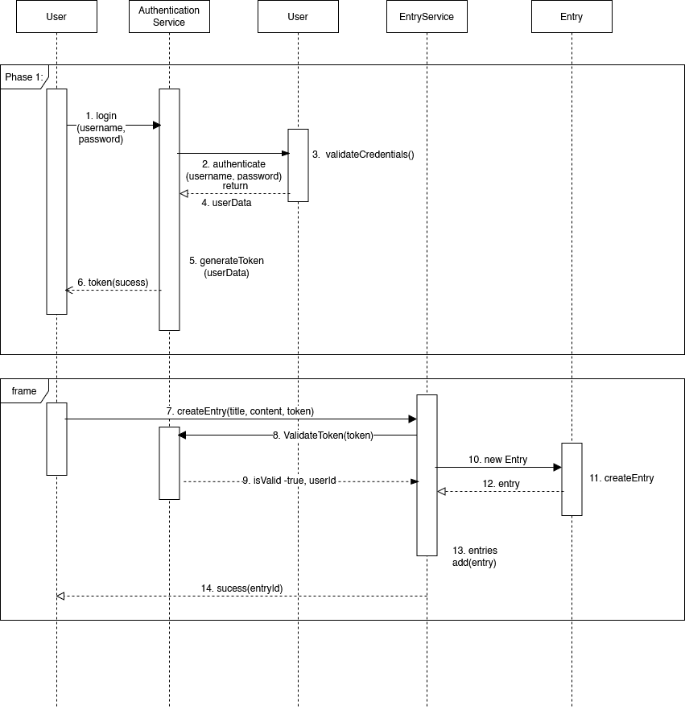
Figure 7: Sequence Diagram for creating Journal Entry
- Process modelling using Activity Diagrams
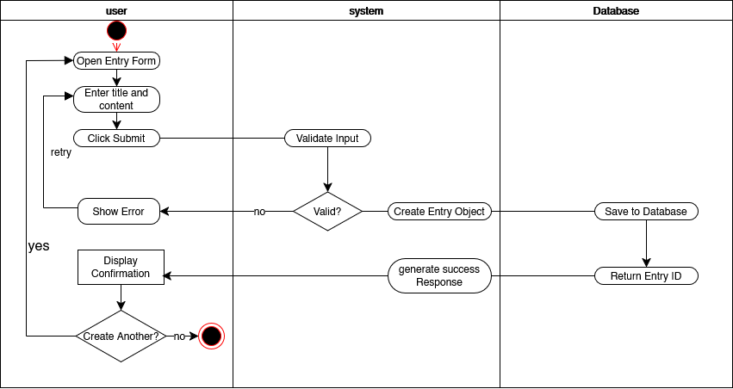
Figure 8: Activity Diagram
The Activity diagram illustrates the workflow of Daily Journal System tlining the sequence of interactions between the user and the API. The process begins with the user initiating authentication by submitting login or registration details. Once the credentials are successfully validated, the system generates a JWT token and returns it to the user for future authorization. Users can create new entries, view existing ones, update previously saved entries, or delete them as required. Each action triggers the system to process the request, interact with the database for storing or retrieving data, and provide an appropriate response back to the user. This activity diagram effectively represents the flow of actions, decision points, authentication checks, and system responses, providing a clear visualization of the complete interaction lifecycle within the DailyJournal system.

Chapter 4: System Design

Design
The design phase focuses on converting the system's conceptual and logical models into a detailed, workable architecture that meets the functional and non-functional requirements. The system design is largely object-oriented, following the structure established during the analysis phase. Key areas of focus include database design, forms and report design, and interface and dialogue design.

4.1.1 Database Design

Figure 9: ER Diagram (4.1)
Based on the above ER diagram, the system’s database desing has been translated into relational tables with proper normalization to minimize redundancy and improve data integrity.
Entries and Attributes:
- Entry: The User table consists of attributes like userId, username, email, and password, with userId as the primary key.
- User: The Entry table stores entryId, title, content, date, and userId, with entryId as the primary key and userId as a foreign key referencing the User table.
A user can have multiple journal entries, forming a one-to-many relationship between User and Entry.

Using the above ER diagram, the entities are mapped to become tables and relationships are mapped using primary keys(PK) and foreign keys (FK)
- User Table

Column Name | Data Type | Constraint
userId | INT | PK
username | VARCHAR | UQ, NOT NULL
email | VARCHAR | UQ, NOT NULL
password | VARCHAR | UQ, NOT NULL
Table 1: User Table (Ch 4.1.1)
- Primary Key (PK): userId — Uniquely identifies each user.
- Unique: username, email are unique across the system.
- Not Null: Ensures that all fields are required for registration.
- Entry Table

Column Name | Data Type | Constraint
entryId | INT | PK
title | VARCHAR | NOT NULL
content | TEXT | NOT NULL
date | DATE | NOT NULL
userId | INT | FK(user)
Table 2: Entry Table (Ch 4.1.1)
Normalization
The database schema is normalized to 3rd Normal Form (3NF) to avoid data duplication and ensure that the database structure supports efficient queries, updates, and deletions. For example: In Daily Journal, The User table stores user-specific data (userId, username, email, password). Each attribute is directly dependent on the primary key userId. There are no non-key attributes that depend on other non-key attributes within the table, thus avoiding transitive dependencies. Similary, The Entry table stores journal entries: entryId, title, content, date, and userId (as a foreign key). In this table, entryId is the primary key. All other attributes (title, content, date, userId) depend directly on entryId. The userId attribute links to the User table but is still a direct property of the entry.
The relationship one-to-many between user and entry and it is handled via the foreign key userId in the Entry table. This avoids repeating user data (e.g., username or email) inside each entry record, which would violate 3NF. Because user data is separated from entry data, any changes to a user’s information (say changing password) need to be made only in the User table, and not scattered across many entry records.

4.1.2 Forms and Report Design
While this project exclusively focuses on the backend, forms and reports for future UI/UX integration yet to be designed. Although the Daily Journal system currently does not have a user interface, future frontend developers can leverage the RESTful API to easily implement forms for user registration, journal entry creation, and viewing/editing entries.
- Forms for user authentication will include fields like username, email, and password.
- Reports will allow users to view their journal entries, sorted by date or title.

4.1.3 Interface and Dialogue Design
The system’s API interface will be documented using Swagger/OpenAPI, providing clear guidelines for how requests and responses should be structured. Although this project doesn’t include a GUI, the API endpoint is designed to accept and return JSON payloads consistently, making them easy to integrate with any front-end or mobile application.

4.1.4 Component Diagrams
• 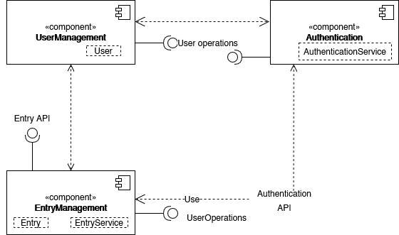
Figure 10: Component Diagram
The component diagram shows how the Daily Journal system is organized into three main parts that work together. They are UserManagement, Authentication, and Entry Management. The UserManagement component manages user accounts and profile actions, while the Authentication component handles login and token verification to keep the system secure. The EntryManagement component manages all journal entry features, such as creating, editing, viewing, and deleting entries. Each component communicates through clear interfaces, making the system easier to maintain, upgrade, and understand.

4.1.5 Deployment Diagrams
The deployment diagram shows how the DailyJournal system is set up across different environments. The application is deployed on a server node where the Spring Boot backend runs, and it connects to a database server that stores user and journal data securely. Users access the system through their devices, such as laptops or mobile phones, by sending requests over the internet. The server processes these requests, handles authentication, performs CRUD operations, and communicates with the database. This structure ensures smooth performance, secure data handling, and easy scalability for future upgrades.
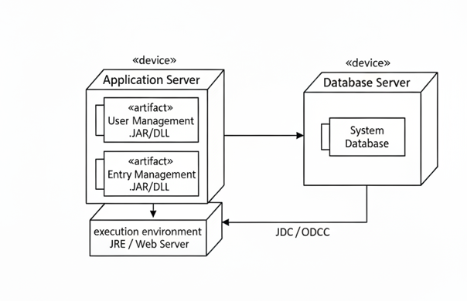
Figure 11: Deployment Diagram

Chapter 5: Implementation and Testing

5.1 Implementation

5.1.1 Tools Used
- CASE tools
For the Daily Journal system, several tools and technologies were selected to support development, deployment, testing, and documentation. The following CASE tools were used:
- Integrated Development Environment (IDE):
  - IntelliJ IDEA: IntelliJ IDEA is a feature-rich, powerful IDE used for developing Java-based applications. It offers advanced features such as code completion, debugging support, and integration with different built in tools, making it an ideal tool for backend development. [11]
  - Visual Studio Code: Visual Studio Code is a lightweight and versatile source code editor that supports various programming languages and is used for editing configuration files, testing API requests, and integrating with version control systems like Git [12].
- Diagramming Tools:
  - Draw.io is the online diagramming tool used to create design diagrams, including Use case diagrams, ER diagrams, Class diagrams, etc. It helps visually represent the system’s structure, data flow, and interactions.
- Version Control Tools
  - Git and GitHub were used to track the changes to our code overtime e nsuring secure access and seamless collaboration among the team members

- Programming Language
- Java: J ava was selected as the primary programming language for backend development through the Spring Boot framework. Java’s robustness, platform independence, and extensive libraries make it ideal for building scalable and secure RESTful APIs. Its object-oriented nature ensures clean, modular, and maintainable code [3]

- Database Platforms
- MySQL: MySQL is a popular open-source relation database management system. MySQL was used to store user data and journal entries in the DailyJournal application, ensuring data consistency, efficient indexing, and relational operations [3]

- Framework
- Spring Boot: Spring Boot is a Java-based framework that simplifies the development of production-ready applications. It reduces configuration complexity, supports dependency injection, and allows for rapid development of RESTful services. Spring Boot’s built-in features, such as embedded servers and security modules, make it a suitable choice for backend development. [2]

5.1.2 Implementation Details of Modules
The implementation of the Daily Journal backend is modularized to ensure clean architecture, scalability, and ease of maintenance. Each module performs a specific set of responsibilities while collaborating to deliver secure, validate, and well-documented API services.
- User Module
This module manages all user-related operations, including account creation, login, and logout.
- UserController handles incoming HTTP requests such as POST /api/auth/register and POST /api/auth/login, and forwards processing to the service layer.
- UserService implements core business logic through methods such as registerUser(), loginUser(), and logoutUser(). During registration, passwords are encrypted using a secure hashing algorithm like BCrypt before being stored.
- UserRepository, extending JpaRepository<User, Long>, provides database interaction for the User entity.

- Authentication Module
This module ensures secure user authorization through JSON Web Tokens (JWT).
- AuthenticationService provides methods like generateToken() and validateToken(). On successful login, a signed JWT is issued containing user details and expiry claims.
- JwtAuthenticationFilter intercepts incoming requests, extracts the token from the Authorization: Bearer <token> header, validates it, and sets the authentication context if valid.

- Entry Module
This module enables users to manage their journal entries.
- EntryController exposes CRUD endpoints, including:
- POST /api/entries
- GET /api/entries
- PUT /api/entries/{id}
- DELETE /api/entries/{id}
- EntryService implements logic for creating, retrieving, updating, and deleting entries. Each action verifies user ownership before processing.
- EntryRepository, extending JpaRepository<Entry, Long>, provides persistence operations.

- Validation & Exception Handling Module
- A GlobalExceptionHandler (with @ControllerAdvice) manages application-wide exceptions like ResourceNotFoundException, UnauthorizedException, and MethodArgumentNotValidException.
- DTO inputs are validated using the @Valid annotation, returning clear error messages for invalid inputs.

- Documentation Module
- API documentation is generated using Swagger/OpenAPI via springdoc-openapi integration, accessible at /swagger-ui/index.html.
- Annotations such as @Operation, @ApiResponses, and @Parameter are used in controllers to enhance API clarity and auto-generate detailed specifications.

Testing

5.2.1 Test Cases for API/Functional Testing
API-level testing was done by using Swagger UI to verify that each endpoint of our application worked properly. Operations such as authentication and CRUD functionalities were tested with different input conditions to ensure proper responses and error handling.
TC | Module | Description | Input Data | Expected Ouput | Result
01 | User Registration | Verify that new user registration works with valid details. | Username:  jane_doe  email: abc@example.com  password: Test@123 | Returns status 201 Created with user details saved in database. | Pass
02 | User Registration | Attempt registration with missing or invalid fields. | username: "", password: "" | Returns status 400 Bad Request with validation error message. | Pass
03 | User Login | Verify login with correct credentials. | email: abc@example.com  password: Test@123 | Returns 401 Unauthorized with error message. | Pass
04 | User Login | Verify login with incorrect password. | email: abc@example.com  password: wrongpass | Returns 401 Unauthorized with error message. | Pass
05 | Create Journal Entry | Verify entry creation with valid JWT token and valid data. | title: “October”  content: “Today, I saw…” | Returns 201 Created with entry details. | Pass
06 | Create Journal Entry | Attempt creation without authentication token. | title: “Unauthorized”, content: “Test content.” | Returns 403 Forbidden or 401 Unauthorized | Pass
07 | Read Journal Entry | Fetch all entries for logged-in user. | Valid JWT token | Returns 200 OK with list of entries for that user. | Pass
08 | Update Journal Entry | Verify update of an existing entry. | entry_id: 1, title: “Updated Title” | Returns 200 OK and updated entry details. | Pass
09 | Delete Journal Entry | Delete entry by ID. | entry_id: 1 | Returns 204 No Content, entry removed from database. | Pass
10 | Validation | Attempt to create entry with missing title or content | title: “”, content: “” | Returns 400 Bad Request with validation error. | Pass
Table 3: Test Cases for Unit Testing

Test Cases for System Testing
These test cases were carried out by using Junit 5 with Spring Boot’s integration with it for testing support. We also utilized MockMvc to perform real HTTP requests to the CRUD endpoints, verifying authentication, authorization. Unlike unit tests that use Mockito for mocking, these are tests that interact with actual components and the test database.
ST | Test Scenario | Test Steps | Expected Output | Actual Ouput | Result
01 | User Registration and Login Flow | Register a new user → login with credentials | Registration returns 201 Created, login returns 200 OK and a valid JWT token | System generates token successfully | Pass
02 | JWT Authentication Validation | Access /api/entries endpoint without JWT token | Request sent without Authorization header | Returns 401 Unauthorized with message “Token Missing or Invalid” | Pass
03 | Create Journal Entry (Authorized) | Send POST /api/entries with valid JWT token and valid data: {"title": "My Day", "content": "Learned Spring Boot"} | Returns 201 Created with entry details stored in database | Entry successfully created | Pass
04 | Fetch All Journal Entries | Send GET /api/entries with valid JWT token | Returns 200 OK with JSON array of all user entries | Entries displayed correctly | Pass
05 | Fetch Single Entry | Send GET /api/entries/{id} for an existing entry | Returns 200 OK with full entry data | Entry details retrieved | Pass
06 | Update Journal Entry | Send PUT /api/entries/{id} with updated title or content | Returns 200 OK, database reflects updated information | Entry updated successfully | Pass
07 | Delete Journal Entry | Send DELETE /api/entries/{id} with valid token | Returns 204 No Content, entry removed from database | Entry deleted successfully | Pass
08 | Validation Handling | Verify update of an existing entry. | Returns 400 Bad Request with validation error message | Error handled correctly | Pass
09 | User Access Control | Attempt to modify another user’s entry using their ID | Returns 403 Forbidden | Unauthorized modification prevented | Pass
10 | Logout (Token Expiry Simulation) | Simulate expired or invalid JWT token and try accessing any endpoint | Returns 401 Unauthorized | System rejects expired/invalid tokens | Pass
Table 4: Test Cases for System Testing

Result Analysis
The Daily Journal system was evaluated based on functionality, performance, usability, and reliability to make sure that it meets the intended project goals. Functional testing confirmed that all core features user authentication, JWT-based authorization, and CRUD operations for journal entries worked correctly. Users were able to securely register, log in, and manage their entries without unauthorized access, demonstrating proper access control. Performance testing showed that the system responded efficiently to API requests, and database operations executed within acceptable time limits for a small to medium dataset. Usability was enhanced with clear API documentation through Swagger, enabling developers to easily understand and test endpoints. The reliability of the application was verified through JUnit test cases, which tested the project through varieties of test cases and ensuring their table behavior across different scenarios.
Overall, the results indicate that the system is secure, efficient, and reliable, fulfilling the key requirements of the project.

Chapter 6: Conclusion

Future Enhancement
While the Daily Journal system meets the core functional and non-functional requirements, several enhancements could be implemented to further improve its capabilities and performance:
- The system could integrate advanced security features like role-based access control (RBAC) or OAuth2 authentication to provide granular control over user permissions and enable secure integration with third-party services.
- The system could be migrated to a cloud environment (e.g., AWS, Azure) to improve scalability and fault tolerance. This would ensure high availability and accommodate a larger number of users as the platform grows.
- Future work could involve building a mobile application to allow users to interact with the system on the go. This could include synchronization of data between devices and offline access to entries.

Conclusion
The Daily Journal backend system successfully implements a secure and scalable platform for users to manage their journal entries. By using modern technologies like Spring Boot, JWT-based authentication, and MySQL, the system ensures a seamless user experience while adhering to security best practices. The system’s use of Swagger/OpenAPI for API documentation further makes it developer-friendliness while Junit for testing further enhances it reliability. Through a combination of RESTful APIs, data validation, and secure authentication mechanisms, the DailyJournal project demonstrates a well-rounded approach to backend development. It provides a solid foundation for personal journaling applications and offers potential for future growth with additional features such as cloud deployment and AI-driven analysis.
Overall, the project not only meets its primary objectives but also sets the stage for further improvements and scalability, ensuring long-term usability and satisfaction for end users.

References

[1] | J. B. N. S. M. Jones, "JSON Web Token (JWT)," RFC 7519, May 2015. [Online]. Available: https://datatracker.ietf.org/doc/html/rfc7519.
[2] | Pivotal Software Inc., "Spring Boot Reference Documentation," [Online]. Available: https://spring.io/projects/spring-boot.
[3] | O. Corporation, "MySQL 8.0 Reference Manual," Oracle, [Online]. Available: https://dev.mysql.com/doc/.
[4] | OpenAPI Initiative, "OpenAPI Specification (Swagger)," Swagger, [Online]. Available: https://swagger.io/specification/.
[5] | O. Foundation, "OWASP Top 10 Security Risk," OWASP, 2024. [Online]. Available: https://owasp.org/Top10/.
[6] | M. Fowler, "Continuous Integration," martinfowler, 18 January 2024. [Online]. Available: https://martinfowler.com/articles/continuousIntegration.html. [Accessed 01 November 2025].
[7] | K. &. A. C. Beck, Extreme Programming Explained: Embrace Change (2nd ed.), Addison-Wesley, 2004.
[8] | R. N. T. Roy T. Fielding, "Principled design of the modern Web architecture," ACM Transaction on Internet Technology, vol. 2, no. 2, pp. 115-150, 2002.
[9] | Wikipedia, "Daylio," Wikimedia, [Online]. Available: https://en.wikipedia.org/wiki/Daylio.
[10] | A. Hussain, E. O. C. Mkpojiogu, I. Hussein, O. M. Muhi and M. H. H. Yosri, " The Effectiveness, Efficiency and Reliability-in-Use of Daylio Mobile App," International Journal of Advanced Science and Technology., vol. 29, no. 8, p. 180–187, 2020.
[11] | JetBrains, "IntelliJ IDEA: The most intelligent Java IDE," JetBrains, [Online]. Available: https://www.jetbrains.com/idea/.
[12] | Visual Studio Code, "Visual Studio Code," Microsoft, [Online]. Available: https://code.visualstudio.com/.

APPENDIX
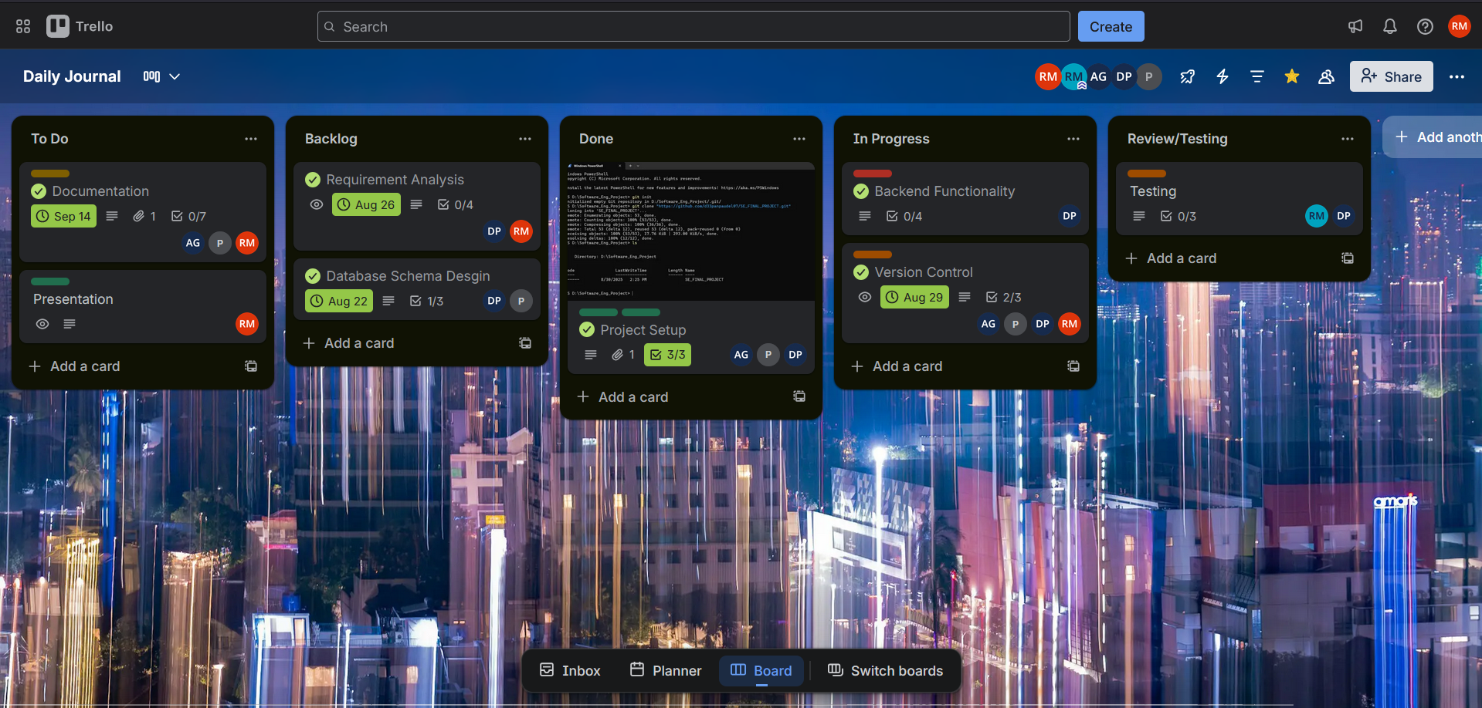
Figure 12: Trello Proof
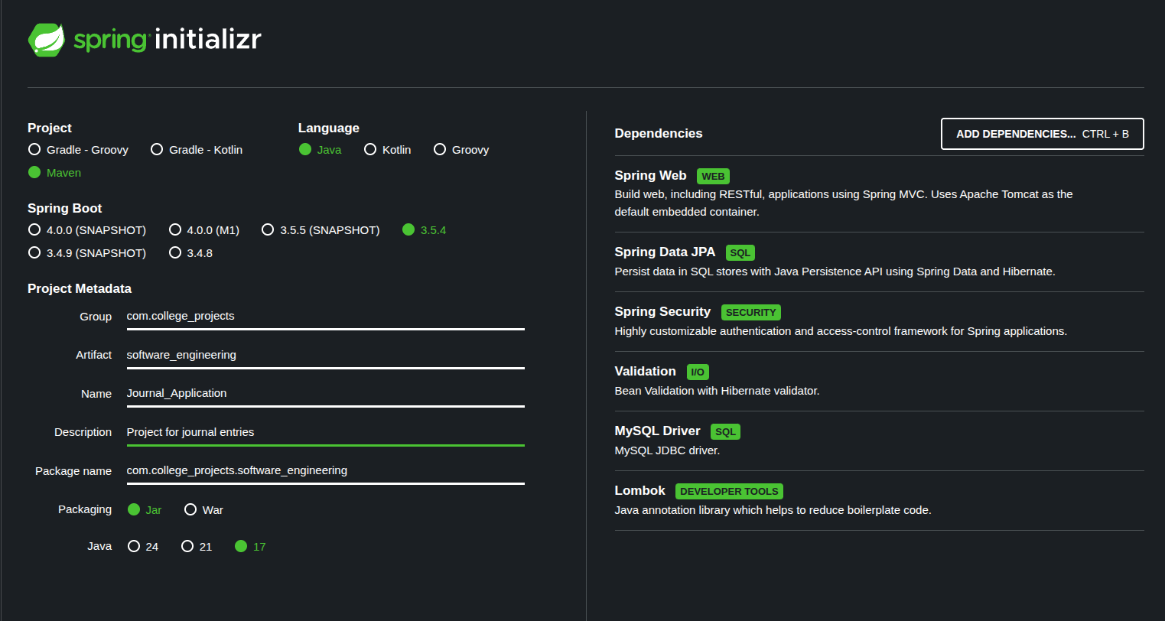
Figure 13: Spring Initializer

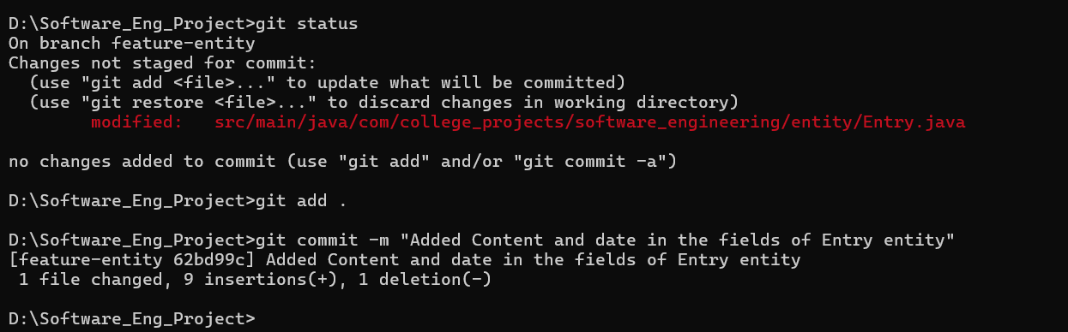
Figure 14: git commit proof
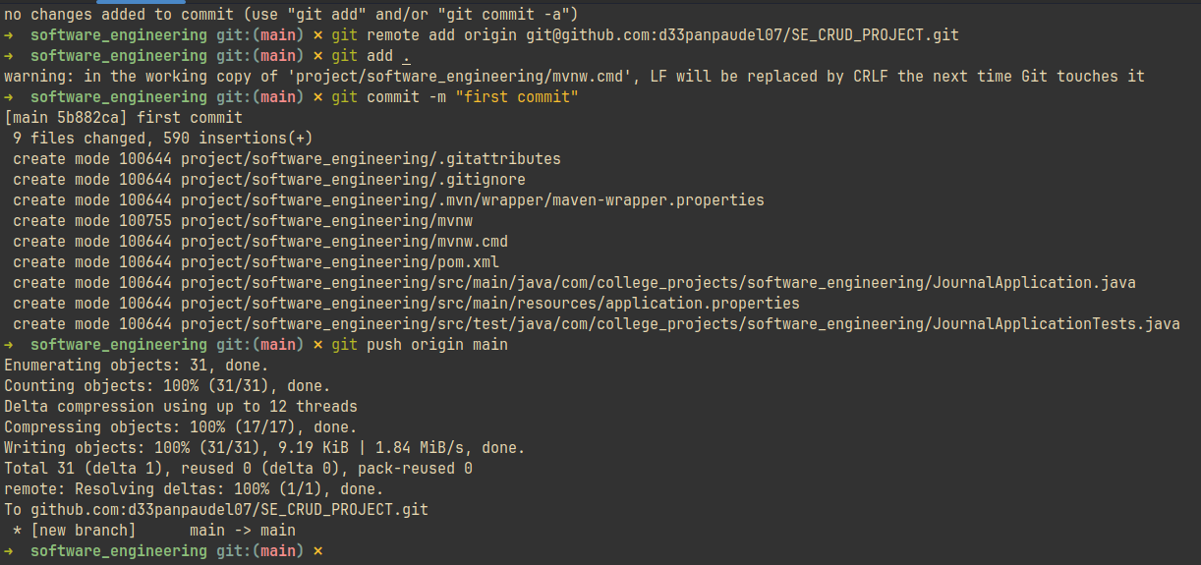
Figure 15: Git Command Proof
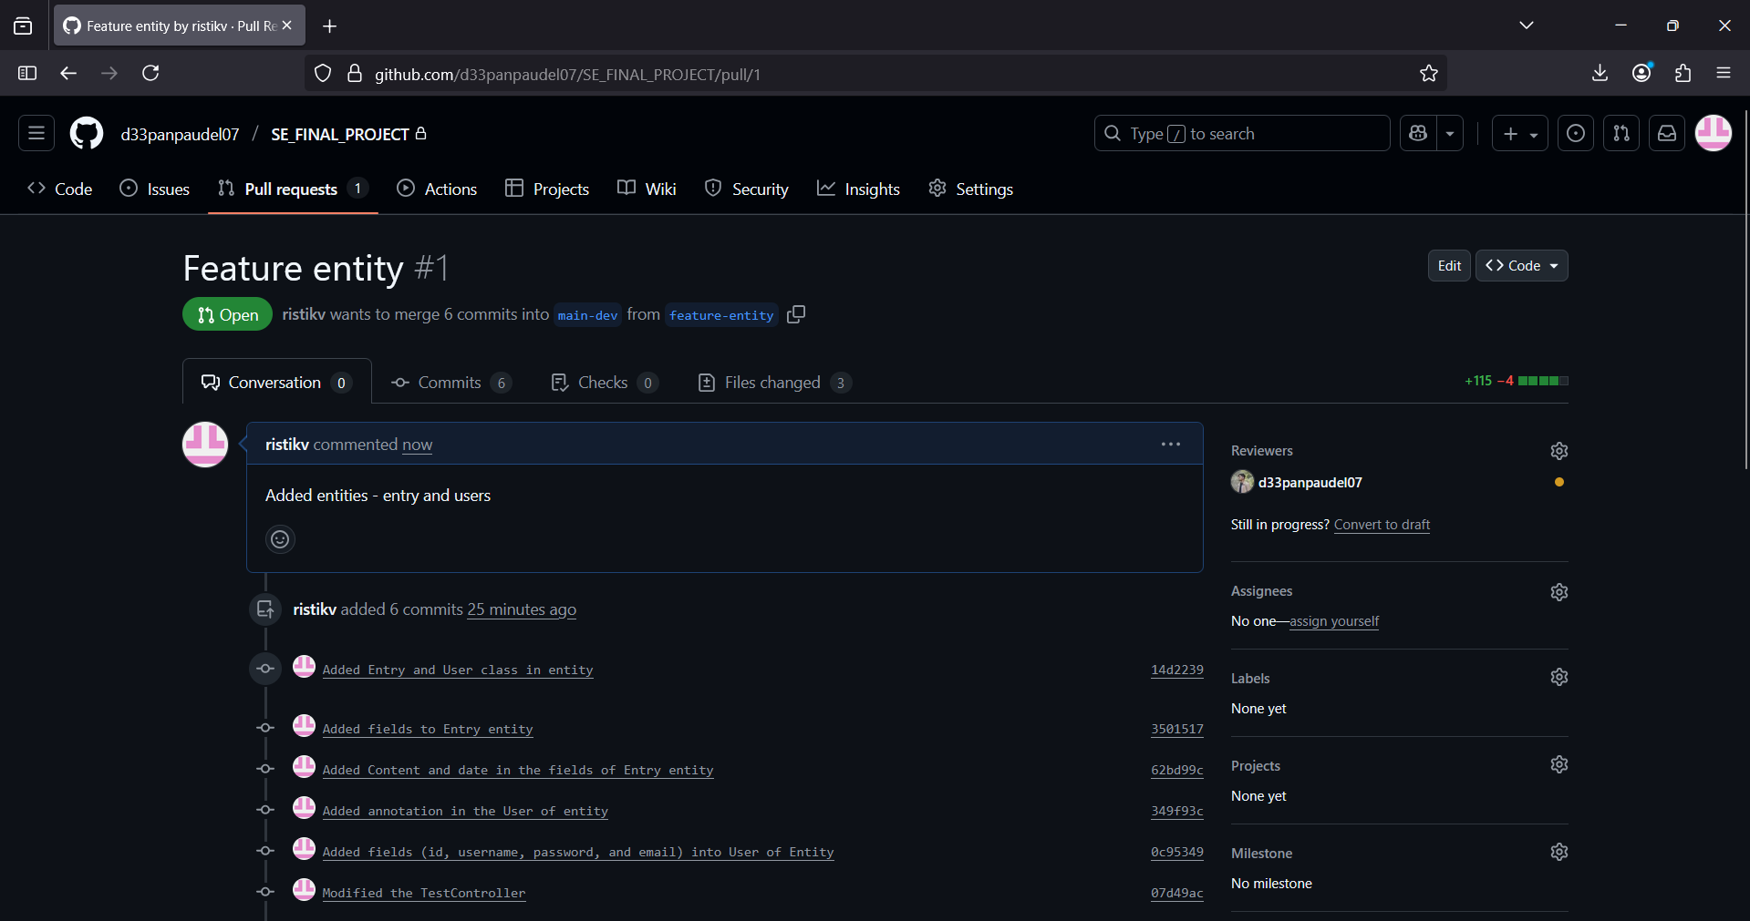
Figure 16: Pull Request Proof
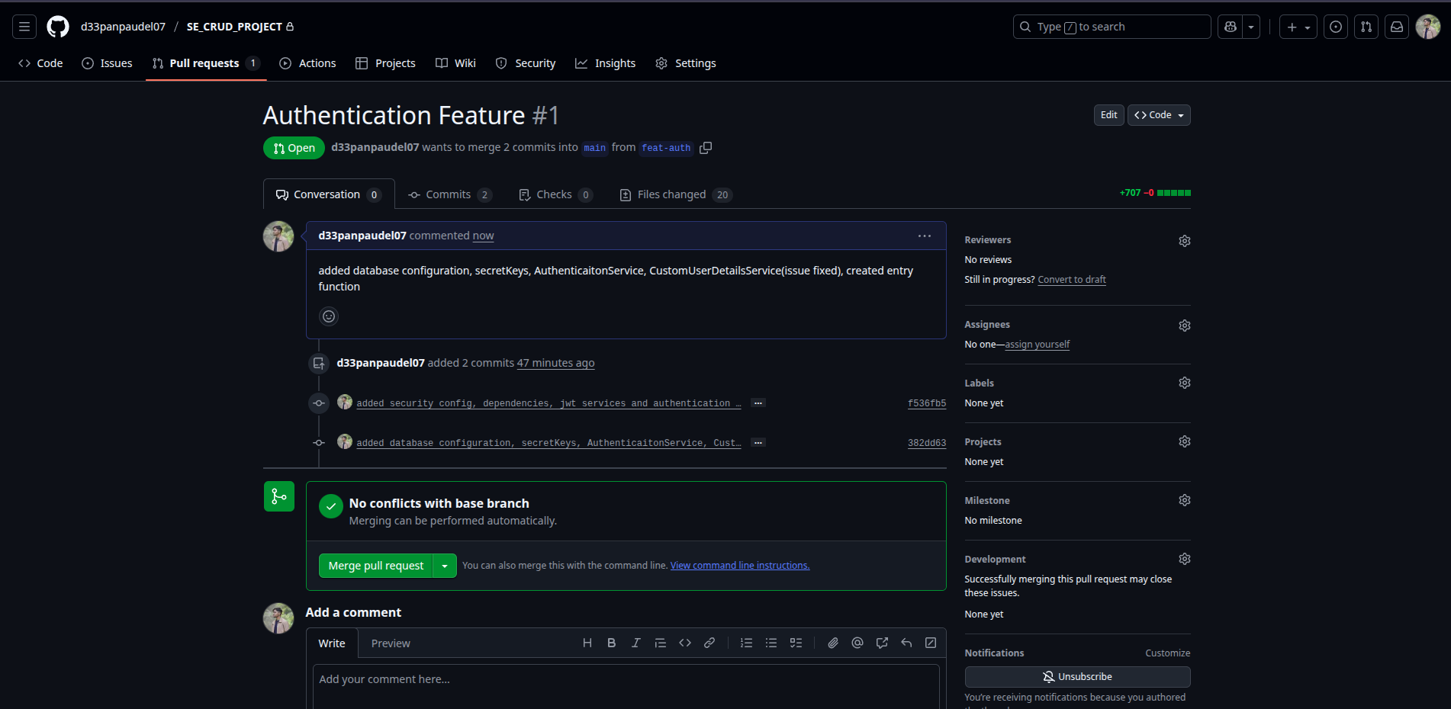
Figure 17: Pull request (new feature is ready to be merged)

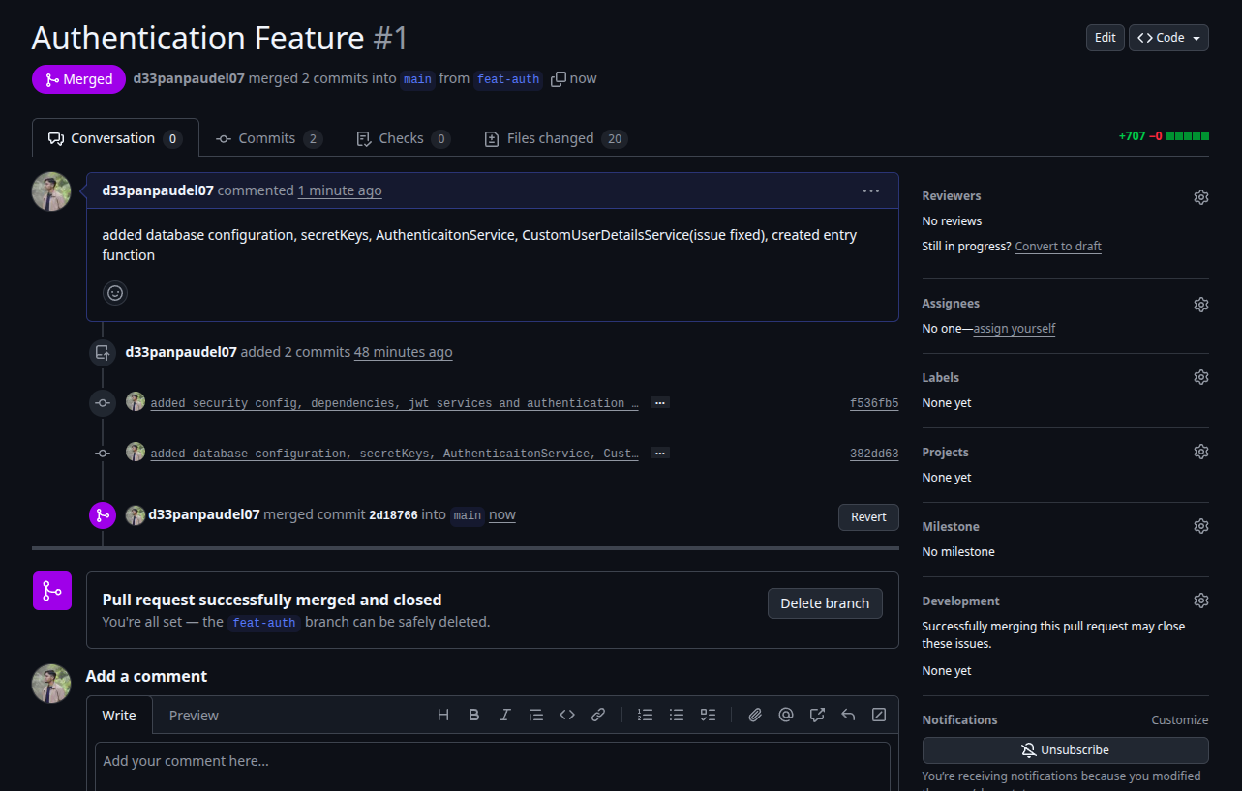
Figure 18: Pull request (sucessfully merged)

